Public IPv4 Address & DNS (Running EC2 Instance)
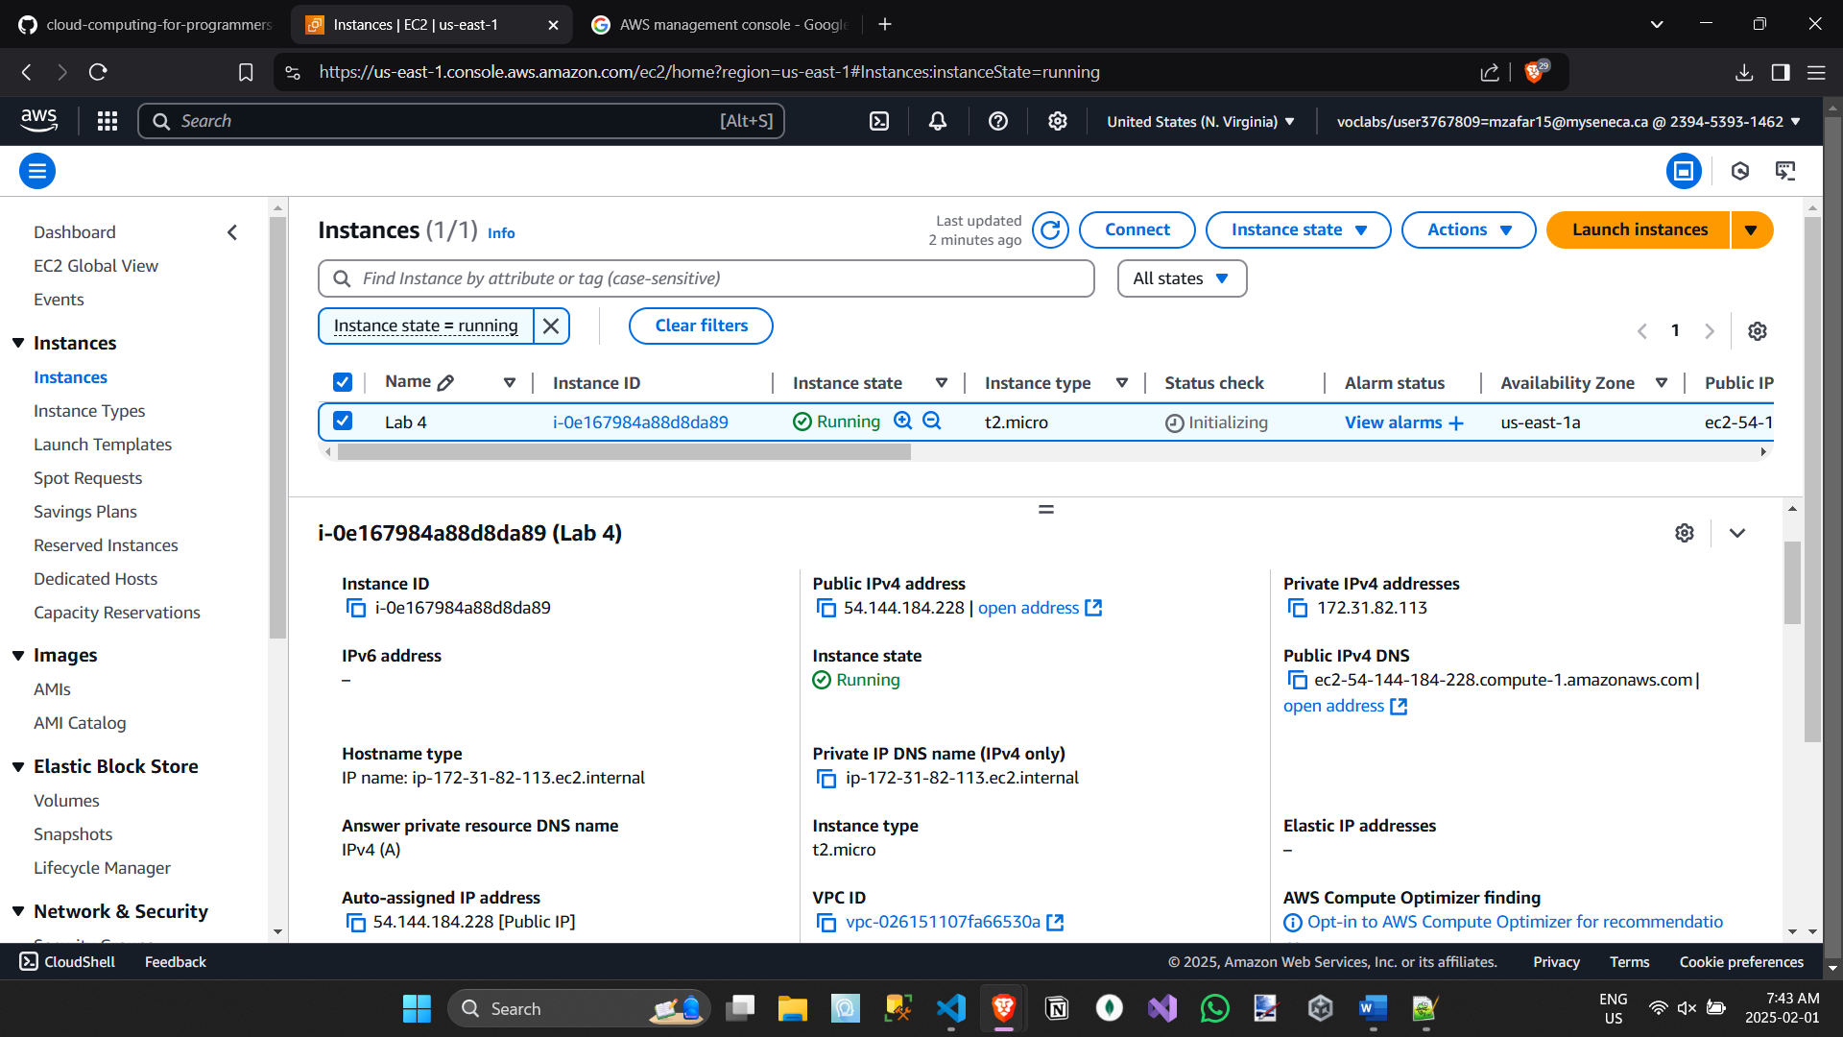
Accessing Microservices health check running on EC2 Via Browser
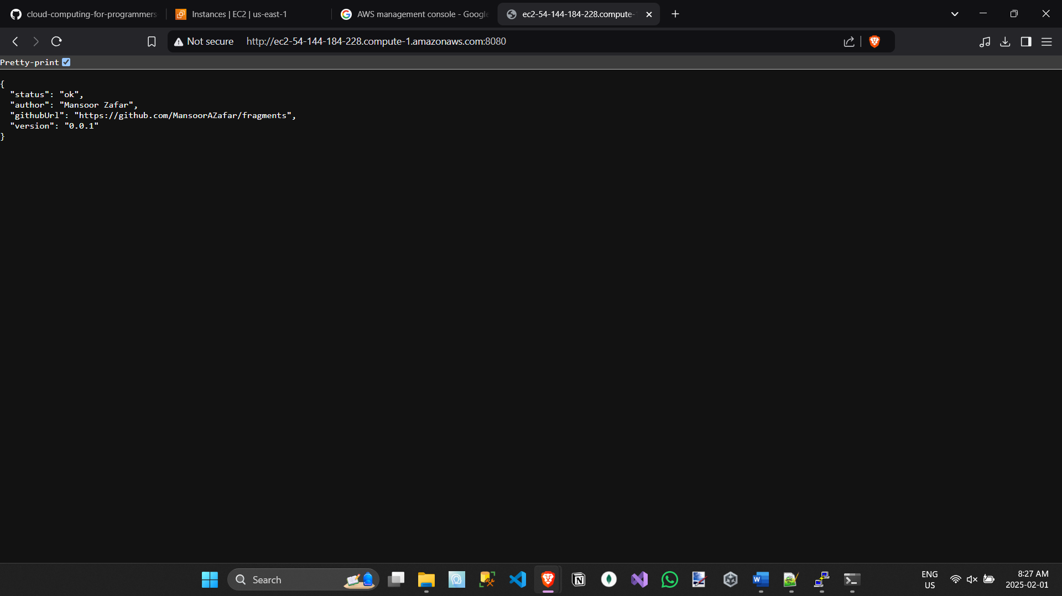
Accessing Microservice health check running on EC2 Via terminal
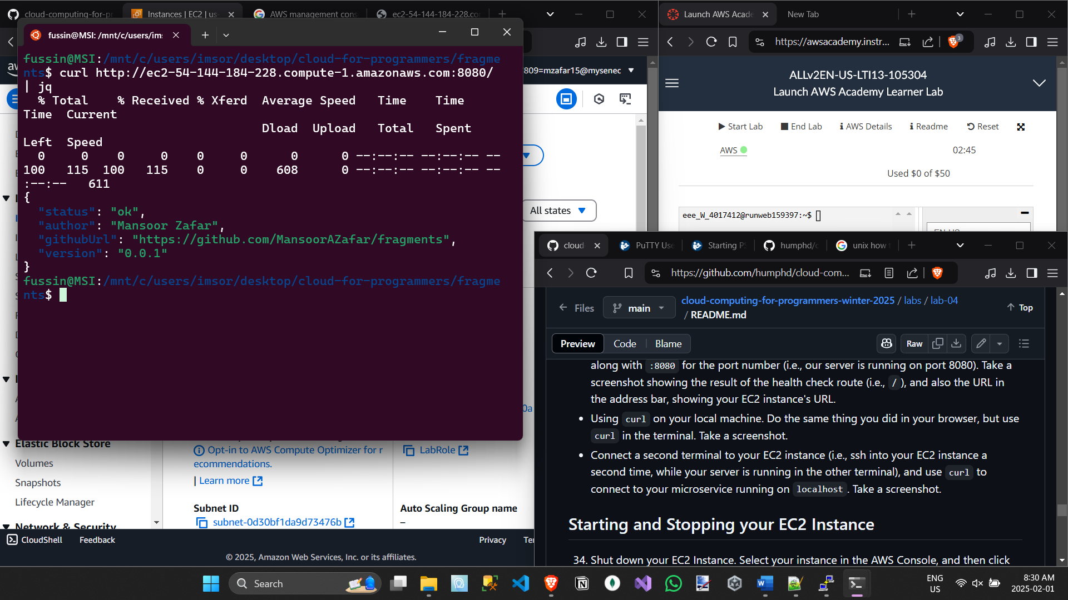
EC2 Instance Duplicate Terminal Curl Localhost
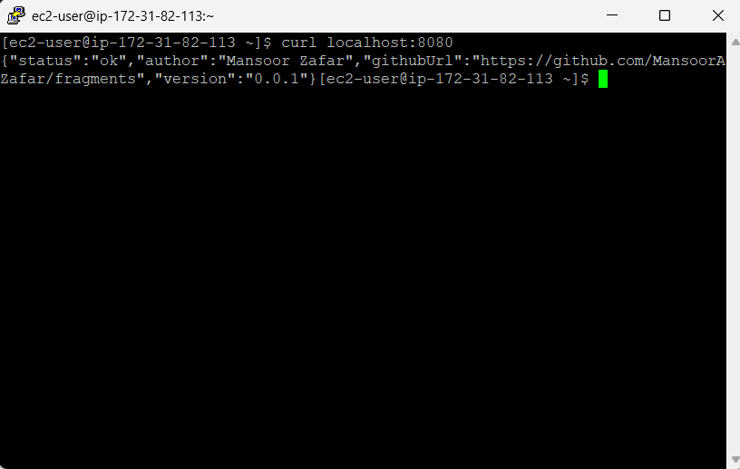
Starting EC2 Instance with AWS CLI
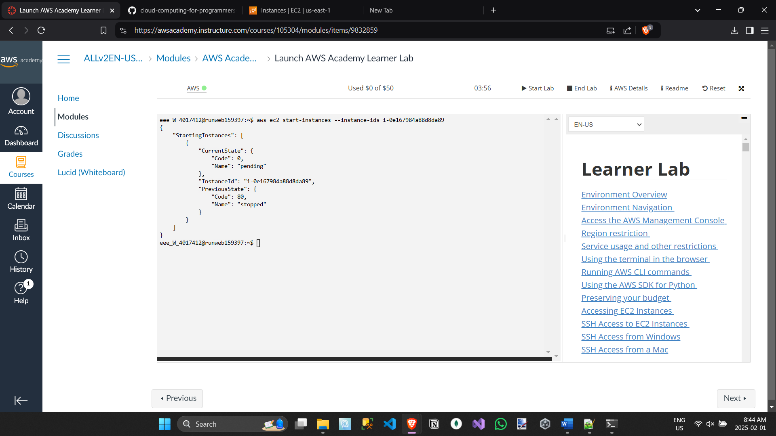
Stopping EC2 Instance with AWS CLI
